Abstract
Sexual size dimorphism (SSD) arises from the interplay between fecundity selection and sexual selection, yet their relative contributions remain poorly understood, particularly in scramble-competitive systems. I investigated the drivers of SSD in an undescribed flightless New Zealand weevil (Lyperobates sp. A) by quantifying fecundity selection on females and multivariate sexual selection on males using body length and hind leg length. Female fecundity increased strongly with body size, indicating pronounced fecundity selection favouring larger females. Contrary to expectations for scramble competition, sexual selection on males favoured larger body size, with larger males achieving higher mating success. Selection was strongly multivariate: males with relatively shorter legs had higher mating success, and significant negative correlational selection indicated that fitness was maximized by specific trait combinations—large body size paired with short legs—producing a ridge-shaped fitness surface. Females experienced directional selection on morphology but showed no evidence of nonlinear or correlational selection. Despite strong selection on both sexes, there was no relationship between male and female body size within mating pairs, indicating an absence of assortative mating. Females were significantly larger than males, confirming female-biased SSD. These results demonstrate that SSD in this species is driven by fecundity selection on females and complex multivariate sexual selection on males, and that scramble competition can favour larger males.

Introduction
Sexual size dimorphism (SSD)—systematic differences in body size between males and females—is a widespread and evolutionarily significant feature of animal morphology (Darwin 1871; Fairbairn et al. 2007). The direction and magnitude of SSD vary widely across taxa, reflecting the balance of sex-specific selection pressures acting on body size (Fairbairn 1997; Blanckenhorn 2000). In many species, male-biased SSD arises through sexual selection driven by male–male competition or female choice (Andersson 1994), whereas female-biased SSD is often attributed to fecundity selection, whereby larger females achieve higher reproductive output (Honek 1993; Kingsolver and Pfennig 2004; Blanckenhorn 2005; Pincheira-Donoso and Hunt 2017; Zhu et al. 2025). However, fecundity selection alone cannot fully explain patterns of SSD, as the evolution of dimorphism also depends critically on the strength and direction of sexual selection acting on males (Blanckenhorn 2000; Fairbairn et al. 2007). Differences between males and females can therefore reflect sex-specific selection regimes acting on morphology, rather than a single uniform process (Judge et al. 2025).
When sexual selection favours increased male size—such as in systems involving male–male contest competition—male-biased SSD may evolve or female-biased SSD may be reduced (Emlen and Oring 1977; Andersson 1994). Conversely, female-biased SSD is expected when sexual selection on males is weak, absent, or favours smaller, more mobile males (Ghiselin 1974; Fairbairn et al. 2007). Scramble-competitive mating systems are often invoked as contexts in which smaller males are favoured because reproductive success depends on efficiently locating and securing mates rather than on direct contests (Andersson 1994; Moya-Laraño et al. 2002). Empirical support for this “mobility hypothesis” comes from systems in which smaller males, or males possessing morphology that enhances locomotor performance, achieve higher mating success, including in Japanese beetles (Popilla japonica), where smaller males with relatively larger wings are more successful (Kelly 2020) in the Cook Strait giant weta (Deinacrida rugosa) where males with smaller bodies and longer legs have greater mating success (Kelly et al. 2008; Kelly and Gwynne 2023). However, this expectation is not universal. Comparative evidence shows that scramble competition encompasses diverse selective regimes and that larger males frequently achieve greater mating success despite the presumed importance of mobility (Herberstein et al. 2017). This suggests that traits such as endurance, mate detection, or persistence can outweigh any locomotor advantages of reduced body size. Thus, predicting the direction of sexual selection on male size in scramble systems requires empirical evaluation rather than reliance on general assumptions.
Patterns of assortative mating can provide insight into how mating interactions are structured with respect to morphology, even in the absence of direct measures of reproductive success. When mating is positively assortative, individuals with similar trait values pair more frequently than expected by chance, which may arise through size-based mate choice, spatial or temporal clustering of similar-sized individuals, or mechanical compatibility (Crespi 1989; Jiang et al. 2013). In contrast, negative assortative mating may occur when dissimilar trait combinations enhance mating success, for example, if size differences facilitate mounting or reflect complementary functional roles during copulation. In scramble-competitive systems, mating is typically driven by encounter rates rather than active mate choice, and therefore assortative mating is often expected to be weak or absent. However, non-random pairing can still arise if body size influences encounter probabilities, mounting success, or males’ ability to maintain contact with females during prolonged copulation (Kelly 2020). Thus, examining assortative mating provides a means of assessing whether pair formation is structured by morphology or occurs largely at random.
Weevils (Curculionoidea) exhibit significant ecological and mating-system diversity across approximately 62,000 species (Haran et al. 2023), with around 1,500 species endemic to New Zealand (May 1993; see also Brown 2017), making them valuable for investigating the role of sexual selection in the evolution of SSD. Within this context, Lyperobates weevils, a genus of flightless, ground-dwelling beetles specific to New Zealand, are typically found in alpine and subalpine habitats (Figure 1). These nocturnal insects occupy structurally complex environments where individuals emerge at night to forage and locate mates. Notably, males do not appear to defend mating-related resources, indicating a scramble-competitive mating system (Thornhill and Alcock 1983; Andersson 1994; Herberstein et al. 2017) in which mate encounter rates and search efficiency are crucial. Once a male successfully locates and mounts a female, he may remain mounted for several hours, copulating intermittently throughout this duration. Here, I investigate sexual size dimorphism in an undescribed species of Lyperobates (Coleoptera: Curculionidae: Entiminae; hereafter Lyperobates sp. A).
I test four predictions in this study. First, I predict that fecundity selection favours larger females, resulting in a positive relationship between female body size and reproductive output. Second, based on classic expectations for scramble competition, I predict that sexual selection on males will be weak or favour smaller body size, while acknowledging that alternative outcomes are possible (Herberstein et al. 2017). Third, I predict that these forces will result in female-biased SSD. Finally, I predict that mating will be random with respect to body size (i.e., no assortative mating), consistent with a scramble-competitive system in which pair formation is driven primarily by encounter processes rather than size-based compatibility or choice.

Methods

Study species
I studied a population of an undescribed species of Lyperobates weevil (hereafter Lyperobates sp. A) collected on Maud Island/Te Hoiere, New Zealand. This taxon is currently under formal description, but can be reliably distinguished from described congeners based on consistent differences in body size, colouration, and elytral morphology (C.D. Kelly, personal observation.). All individuals used in this study conformed to this diagnostic phenotype and are treated as a single, cohesive lineage.
Adult weevils were collected on 11 nights between 20 April and 5 May 2007 on Maud Island/Te Hoiere, New Zealand. Individuals were opportunistically located at night by searching the ground and low vegetation (≤ 2 m height) along a 20 m section of track bordering forest habitat. Sampling commenced approximately 1 hour after sunset (~18:30 h) and continued for two hours. Weevils were found almost exclusively on the leaves of kawakawa (Piper excelsum). Each observed male–female pair (N = 25), along with singleton males (N = 75) and females (N = 52), was collected and placed individually into 50 mL Falcon tubes, assigned a unique identification code, and transported to a field laboratory on Maud Island. Specimens were subsequently euthanized by freezing. All individuals were digitally photographed alongside a ruler for scale. Females (N=69) were dissected to quantify fecundity by counting the number of eggs present in the reproductive tract. Morphological measurements were obtained from digital images using Fiji (Schindelin et al. 2012), including body length (from the anterior edge of the thorax to the posterior edge of the abdomen) and hind leg length (third pair; from the proximal end of the femur to the distal end of the tibia), measured to the nearest 0.01 mm.

Statistical analyses
All analyses were conducted in R (R Core Team 2025). Morphological traits were measured as total body length and total hind leg length. Sex differences in these traits were first assessed using linear models with sex as a fixed effect. Additionally, I performed a multivariate analysis of variance (MANOVA) to test for overall sexual dimorphism across traits.
To quantify the strength and form of selection on total body length and total hind leg length, I estimated standardized selection differentials and gradients following Lande and Arnold (1983) using the gsg R package (Morrissey and Sakrejda 2013). Both traits were standardized to mean zero and unit variance prior to analysis. Directional selection differentials (S) were calculated as the covariance between each trait and relative fitness (Lande and Arnold 1983). Selection gradients were used to estimate direct selection on traits: linear gradients (β) describe directional selection, quadratic gradients (γ) describe nonlinear (stabilizing or disruptive) selection, and correlational gradients (γᵢⱼ) describe selection on trait combinations (Phillips and Arnold 1989; Brodie et al. 1995). Fitness was modeled as a function of total body length and total hind leg length using spline-based generalized additive models (Wood 2017), which allow flexible estimation of fitness surfaces without assuming a specific functional form and accommodate non-normal fitness distributions. Male mating success was treated as a binomial response (mated = 1, unmated = 0). Selection gradients (β, γ, γᵢⱼ) were estimated separately for each sex using standardized traits. Statistical significance was assessed using permutation tests implemented in gsg (Morrissey and Sakrejda 2013), where trait–fitness associations were randomized to generate null distributions.
Female fecundity selection was analyzed using a negative binomial generalized linear model (GLM) to account for overdispersion in egg counts (Venables and Ripley 2002). Egg number was modeled as a function of log-transformed body size.
Assessing assortative mating provides insight into whether mating pairs are structured by morphology or form independently of body size. I evaluated assortative mating by testing for a relationship between male and female body size within mating pairs using linear regression on standardized traits (Crespi 1989; Jiang et al. 2013).To determine whether the observed slope differed from random expectations, I performed a permutation test in which pairings were randomized and slopes recalculated across iterations.

Results

Fecundity selection on females
In support of my first prediction, female fecundity increased significantly with body size (Figure 2), consistent with the widely reported positive relationship between body size and egg production in insects (Honek 1993; Kingsolver and Pfennig 2004). Egg number was positively related to log-transformed body length ($β$ = 4.50 ± 1.33, z = 3.39, p<0.001), indicating strong fecundity selection favouring larger females.

Sexual selection on males
Contrary to my second prediction, I found no evidence that sexual selection favours smaller males (Table 1). Instead, male body length was under strong positive directional selection ($β$_{i} = 0.97 ± 0.24, p<0.001), indicating that larger males achieved higher mating success (Figure 3 a). This pattern is inconsistent with predictions of scramble-competition theory (Moya-Laraño et al. 2002; Kelly et al. 2008; Herberstein et al. 2017).
Selection was multivariate in both sexes (Phillips and Arnold 1989), indicating that fitness depended on combinations of traits rather than traits in isolation. In males, body length experienced positive directional selection, whereas hind leg length was under significant negative directional selection ($β$_{j} = -0.95 ± 0.25, p<0.001; Figure 3 b), indicating that males with relatively shorter legs had higher mating success.
In addition to directional effects, both male traits exhibited significant nonlinear selection (Table 1). Body length showed positive quadratic selection ($γ$_{ii} = 1.20 ± 0.71, p<0.001; Figure 3 b), and leg length also experienced positive quadratic selection ($γ$_{jj} = 1.17 ± 0.71, p<0.001; Figure 3 b), indicating curvature in the fitness surface. Importantly, I also detected significant negative correlational selection between traits ($γ$_{ij} = -0.59 ± 0.33, p=0.456). The fitness surface (Figure 4) reveals that this interaction strongly shapes the adaptive landscape, with mating success highest for males with large bodies and relatively short legs. This produces a ridge-like fitness surface, rather than independent optima for each trait.
In females, directional selection was also evident: body length was under positive selection ($β$_{i} = 0.93 ± 0.39, p=0.036), while leg length was under strong negative selection ($β$_{j} = -1.22 ± 0.33, p<0.001; Figure 4). However, I detected no evidence for nonlinear (Table 1) or correlational selection in females ($γ$_{ij} = -0.23 ± 0.49, p=0.456).

Sexual size dimorphism
Consistent with my third prediction, females were significantly larger than males in both total body length and total hind leg length (Figure 5), demonstrating pronounced female-biased sexual size dimorphism (SSD), a pattern widely observed across insects (Blanckenhorn 2000; Fairbairn et al. 2007). Mean body length was 9.95 ± 0.07 mm (n = 77) in females and 8.95 ± 0.04 mm (n = 100) in males, indicating that females were approximately 11.2% larger than males (female:male ratio = 1.11). Linear modelling confirmed that males were, on average, 1.00 mm shorter than females ($β$ = -1.00 ± 0.08, t = -13.34, p<0.001; R² = 0.50.
Hind leg length showed a similar pattern, with females exhibiting longer legs than males (7.05 ± 0.04 mm vs. 6.68 ± 0.03 mm), corresponding to a 5.5% increase in females (ratio = 1.06). This difference was also statistically significant ($β$ = -0.37 ± 0.05, t = -6.95, p<0.001; R² = 0.22). A multivariate analysis confirmed strong overall sexual dimorphism across traits (MANOVA: Pillai’s trace = 0.57, F_{2,174} = 117.46, p<0.001).

Assortative mating
There was no evidence of assortative mating. The relationship between male and female body size within mating pairs was weak and non-significant ($β$ = -0.23 ± 0.20, t = -1.14, p=0.265), and did not differ from random expectations (P = 0.393). Thus, mating appeared random with respect to body size.

Discussion
Although Lyperobates sp. A remains formally undescribed, multiple lines of evidence indicate that it represents a distinct and cohesive taxonomic entity. All individuals examined shared consistent morphological characteristics, and only a single morphotype was encountered at the study site. It is therefore appropriate to treat this taxon as a single species for the purposes of analyzing patterns of selection and sexual size dimorphism.
Female Lyperobates sp. A were significantly larger than males, confirming pronounced female-biased sexual size dimorphism (SSD). This pattern is consistent with extensive evidence across insects showing that fecundity selection favours increased female size (Honek 1993; Kingsolver and Pfennig 2004; Blanckenhorn 2005; Fairbairn et al. 2007; Pincheira-Donoso and Hunt 2017). Strong support for this mechanism was evident in this system, as larger females carried more eggs, demonstrating that increased body size directly enhances reproductive output. These results indicate that fecundity selection is sufficiently strong to drive divergence in body size between the sexes. More broadly, this pattern is consistent with models of sex-role evolution in which fe males are constrained by the costs of egg production, reducing selection for active mate searching and instead favouring greater investment in reproduction (Fromhage et al. 2016).
Contrary to classic expectations for scramble-competitive mating systems, sexual selection favoured larger males rather than smaller, more mobile individuals (Andersson 1994; Moya-Laraño et al. 2002; Fairbairn et al. 2007). Larger males achieved higher mating success, indicating strong positive directional selection on body length. Although scramble competition is often assumed to favour reduced size due to advantages in mobility, empirical and comparative evidence suggest that this expectation is not universal (Herberstein et al. 2017). For example, sexual selection favours smaller, more mobile males in some systems, such as Japanese beetles and giant weta (Kelly et al. 2008; Kelly 2020; Kelly and Gwynne 2023), whereas in others, larger males achieve higher mating success despite the presumed importance of mobility. These findings indicate that the direction of sexual selection on male size is highly context-dependent and cannot be predicted solely from mating system classification. In this system, traits associated with encounter rate, persistence, or the ability to maintain contact with females may outweigh any locomotor advantages of smaller size.
Sexual selection on males was strongly multivariate (Phillips and Arnold 1989; Brodie et al. 1995). In addition to positive directional selection on body length, males with relatively shorter hind legs achieved higher mating success, and I detected significant negative correlational selection between these traits. This indicates that fitness is maximized by specific trait combinations rather than by independent trait values. The resulting fitness surface is ridge-shaped, with highest mating success achieved by males combining large body size with relatively short legs. This finding refines a simple “bigger is better” interpretation of sexual selection. Although larger males generally have higher mating success, this advantage depends on their associated morphology. Such correlational selection implies functional integration among traits, likely reflecting performance trade-offs that influence mate-search efficiency, mating stability, or endurance. More broadly, this result highlights that interpreting selection on individual traits in isolation can be misleading when fitness depends on trait combinations (Phillips and Arnold 1989).
In contrast to males, females experienced directional selection on morphology but showed no evidence of nonlinear or correlational selection. Body length was under positive selection, whereas hind leg length was under negative selection, suggesting that similar trait axes influence fitness in both sexes but with simpler, largely additive effects in females. The absence of multivariate selection in females may reflect differences in how morphology influences reproductive success, with fecundity primarily determined by body size rather than by complex trait interactions (Honek 1993; Kingsolver and Pfennig 2004).
I found no evidence of assortative mating with respect to body size, indicating that mating pairs form independently of size similarity or dissimilarity between males and females. This result is consistent with expectations for scramble-competitive systems, in which pair formation is largely driven by encounter processes rather than active mate choice (Crespi 1989; Jiang et al. 2013). The absence of assortative mating suggests that, despite strong sexual selection on male morphology, body size does not structure mate choice. In particular, males with phenotypes favoured by selection—those with relatively large bodies and shorter legs—do not preferentially pair with females of any particular size. This decoupling between selection on individual traits and the structure of mating pairs highlights that the processes determining mating success need not generate non-random pairing patterns (McDonald and Pizzari 2016).
My results demonstrate that female-biased SSD in this Lyperobates weevil arises from the combined effects of strong fecundity selection on females and multivariate sexual selection on males. While sexual selection favours increased male body size, this effect is contingent on trait combinations, emphasizing the importance of correlational selection in shaping male morphology. This pattern is consistent with broader comparative work showing that SSD often reflects the combined effects of fecundity selection on females and sexual selection on males, with the balance between these forces varying across taxa (Stillwell et al. 2010). At the same time, the absence of assortative mating indicates that mating structure neither reinforces nor constrains these selective patterns, in contrast to systems where non-random mating can strengthen or weaken sexual selection (McDonald and Pizzari 2016; Kelly and Gwynne 2023). More broadly, these findings highlight that the evolution of SSD depends not only on the strength and direction of selection acting on individual traits, but also on how traits interact to influence performance and fitness.
Several limitations of my study should be noted. Male mating success was measured as a binary outcome, which may obscure variation in reproductive success among mated individuals. In addition, sampling was restricted to a limited temporal window, and behavioural observations were insufficient to directly link morphology to specific mating tactics. Future work should integrate behavioural observations, experimental manipulations, and network-based analyses of mating interactions to better understand how trait combinations influence both mating success and fertilization outcomes.
In conclusion, this study shows that female-biased SSD in an undescribed Lyperobates weevil is driven by strong fecundity selection on females combined with complex, multivariate sexual selection on males. The presence of strong correlational selection indicates that male fitness depends on integrated trait combinations rather than body size alone. These results highlight the importance of adopting a multivariate perspective when studying sexual selection and the evolution of dimorphism, particularly in systems traditionally assumed to follow simple theoretical expectations.

References
Andersson MB. 1994. Sexual Selection. Princeton University Press.
Blanckenhorn WU. 2000. The evolution of body size: What keeps organisms small? The Quarterly Review of Biology. 75(4):385–407
Blanckenhorn WU. 2005. Behavioral causes and consequences of sexual size dimorphism. Ethology. 111(11):977–1016. https://doi.org/10.1111/j.1439-0310.2005.01147.x
Brodie ED, Moore AJ, Janzen FJ. 1995. Visualizing and quantifying natural selection. Trends Ecol Evol. 10(8):313–8. https://doi.org/10.1016/S0169-5347(00)89117-X
Brown SDJ. 2017. Austromonticola, a new genus of broad-nosed weevil (Coleoptera, Curculionidae, Entiminae) from montane areas of New Zealand. Zookeys. (707):73–130. https://doi.org/10.3897/zookeys.707.12649
Crespi BJ. 1989. Causes of assortative mating in arthropods. Animal Behaviour. 38(6):980–1000. https://doi.org/10.1016/S0003-3472(89)80138-1
Darwin C. 1871. The Descent of Man, and Selection in Relation to Sex. John Murray p viii, 423. (The descent of man, and Selection in relation to sex, Vol 1.). https://doi.org/10.1037/12293-000
Emlen ST, Oring LW. 1977. Ecology, sexual selection, and the evolution of mating systems. Science. 197(4300):215–223. https://doi.org/10.1126/science.327542
Fairbairn DJ. 1997. Allometry for sexual size dimorphism: Pattern and process in the coevolution of body size in males and females. Annual Review of Ecology, Evolution, and Systematics. 28(Volume 28, 1997):659–687 [accessed 2026 Apr 11]. https://doi.org/10.1146/annurev.ecolsys.28.1.659
Fairbairn DJ, Blanckenhorn WU, Székely T. 2007. Sex, Size and Gender Roles. Oxford University Press.
Fromhage L, Jennions M, Kokko H. 2016. The evolution of sex roles in mate-searching. Evolution. 70. https://doi.org/10.1111/evo.12874
Ghiselin MT. 1974. The Economy of Nature and the Evolution of Sex. Univ of California Press.
Haran J et al. 2023. Phylogenomics illuminates the phylogeny of flower weevils (Curculioninae) and reveals ten independent origins of brood-site pollination mutualism in true weevils. Proc Biol Sci. 290(2008):20230889. https://doi.org/10.1098/rspb.2023.0889
Herberstein ME, Painting CJ, Holwell GI. 2017. Scramble competition polygyny in terrestrial arthropods. In: Advances in the of. Elsevier; p 237–295. https://doi.org/10.1016/bs.asb.2017.01.001
Honek A. 1993. Intraspecific variation in body size and fecundity in insects: A general relationship. Oikos. 483–492. https://doi.org/10.2307/3544943
Jiang Y, Bolnick DI, Kirkpatrick M. 2013. Assortative mating in animals. American Naturalist. 181(6):E125–38. https://doi.org/10.1086/670160
Judge KA et al. 2025. Sexual size and shape dimorphism are consistent with predictions that both natural and sexual selection are driving the evolution of sexual dimorphism in Mormon crickets, Anabrus Simplex. BMC Ecol Evol. 25(1):60. https://doi.org/10.1186/s12862-025-02401-y
Kelly CD. 2020. Sexual selection on the size and shape of morphological traits in the Japanese beetle (Popillia Japonica). Behavioral Ecology. 31:1073–1083. https://doi.org/10.1093/beheco/araa054
Kelly CD, Bussière LF, Gwynne DT. 2008. Sexual selection for male mobility in a giant insect with female-biased size dimorphism. The American Naturalist. 172(3):417–423. https://doi.org/10.1086/589894
Kelly CD, Gwynne DT. 2023. Mating assortment and the strength of sexual selection in a polyandrous population of Cook Strait giant weta. Behavioral Ecology. 34:506–513. https://doi.org/10.1093/beheco/arad017/49802299/arad017.pdf
Kingsolver JG, Pfennig DW. 2004. Individual-level selection as a cause of Cope’s rule of phyletic size increase. Evolution. 58(7):1608–1612. https://doi.org/10.1111/j.0014-3820.2004.tb01740.x
Lande R, Arnold SJ. 1983. The measurement of selection on correlated characters. Evolution. 37(6):1210–1226. https://doi.org/10.2307/2408842
May BM. 1993. Larvae of Curculionoidea (Insecta: Coleoptera): A systematic overview. Fauna of New Zealand. 28
McDonald GC, Pizzari T. 2016. Why patterns of assortative mating are key to study sexual selection and how to measure them. Behav Ecol Sociobiol. 70:209–220. https://doi.org/10.1007/s00265-015-2041-7
Morrissey MB, Sakrejda K. 2013. Unification of regression-based methods for the analysis of natural selection. Evolution. 67(7):2094–100. https://doi.org/10.1111/evo.12077
Moya-Laraño J, Halaj J, Wise DH. 2002. Climbing to reach Romeo should be small. Evolution. 56(2):420–425
Phillips PC, Arnold SJ. 1989. Visualizing multivariate selection. Evolution. 43(6):1209–1222. https://doi.org/10.2307/2409357
Pincheira-Donoso D, Hunt J. 2017. Fecundity selection theory: Concepts and evidence. Biol Rev Camb Philos Soc. 92(1):341–356
R Core Team. 2025. R: A language and environment for statistical computing.
Schindelin J et al. 2012. Fiji: An open-source platform for biological-image analysis. Nature Methods. 9(7):676–82. https://doi.org/10.1038/nmeth.2019
Stillwell RC et al. 2010. Sex differences in phenotypic plasticity affect variation in sexual size dimorphism in insects: From physiology to evolution. Annu Rev Entomol. 55:227–45. https://doi.org/10.1146/annurev-ento-112408-085500
Thornhill R, Alcock J. 1983. The Evolution of Insect Mating Systems. Harvard University Press. [accessed 2026 Apr 12]. https://doi.org/10.4159/harvard.9780674433960
Venables WN, Ripley BD. 2002. Modern Applied Statistics with S. Springer.
Wood SN. 2017. Generalized Additive Models: An Introduction with R, Second Edition. 2nd ed. Chapman and Hall/CRC. https://doi.org/10.1201/9781315370279
Zhu M et al. 2025. Scaling relationships and sexual size dimorphism among the body parts of Holotrichia Oblita (Coleoptera: Scarabaeidae). Ecol Evol. 15(7):e71760. https://doi.org/10.1002/ece3.71760

Table 1: Selection differentials (S, C) and standardized linear (β) and quadratic (γ) selection gradients for body length and leg length in female and male Lyperobates spp. weevils. Estimates are presented as mean ± SE. Differentials quantify total selection acting on traits, whereas gradients estimate direct selection after accounting for trait correlations. Linear gradients (β) describe directional selection, and quadratic gradients (γ) capture nonlinear selection (stabilizing or disruptive). P-values are shown for each estimate, and statistically significant effects (P < 0.05) are indicated in bold.
 |  | Differentials |  |  |  |  | Gradients
 | Trait | S ± SE | P | C ± SE | P |  | β ± SE | P | γ ± SE | P
(a) Females
 | body length | -0.040 ± 0.148 | 0.775 | -0.388 ± 0.223 | 0.094 |  | 0.930 ± 0.388 | 0.036 | -1.186 ± 4.185 | 0.410
 | leg length | -0.148 ± 0.150 | 0.325 | -0.246 ± 0.215 | 0.275 |  | -1.224 ± 0.333 | <0.001 | 0.907 ± 0.825 | 0.094
(b) Males
 | body length | 0.210 ± 0.165 | 0.197 | -0.092 ± 0.200 | 0.618 |  | 0.968 ± 0.244 | <0.001 | 1.203 ± 0.706 | <0.001
 | leg length | -0.175 ± 0.168 | 0.305 | -0.121 ± 0.212 | 0.551 |  | -0.954 ± 0.249 | <0.001 | 1.169 ± 0.712 | <0.001

Figure 1: Mating pair of Lyperobates sp. A weevils. The male is mounted dorsally on the female in a typical copulatory position. (a) Lateral (side) view showing the male positioned atop the female’s abdomen, with legs grasping the female’s body. (b) Frontal view illustrating the alignment of the pair and relative positioning of the male on the female’s dorsum.

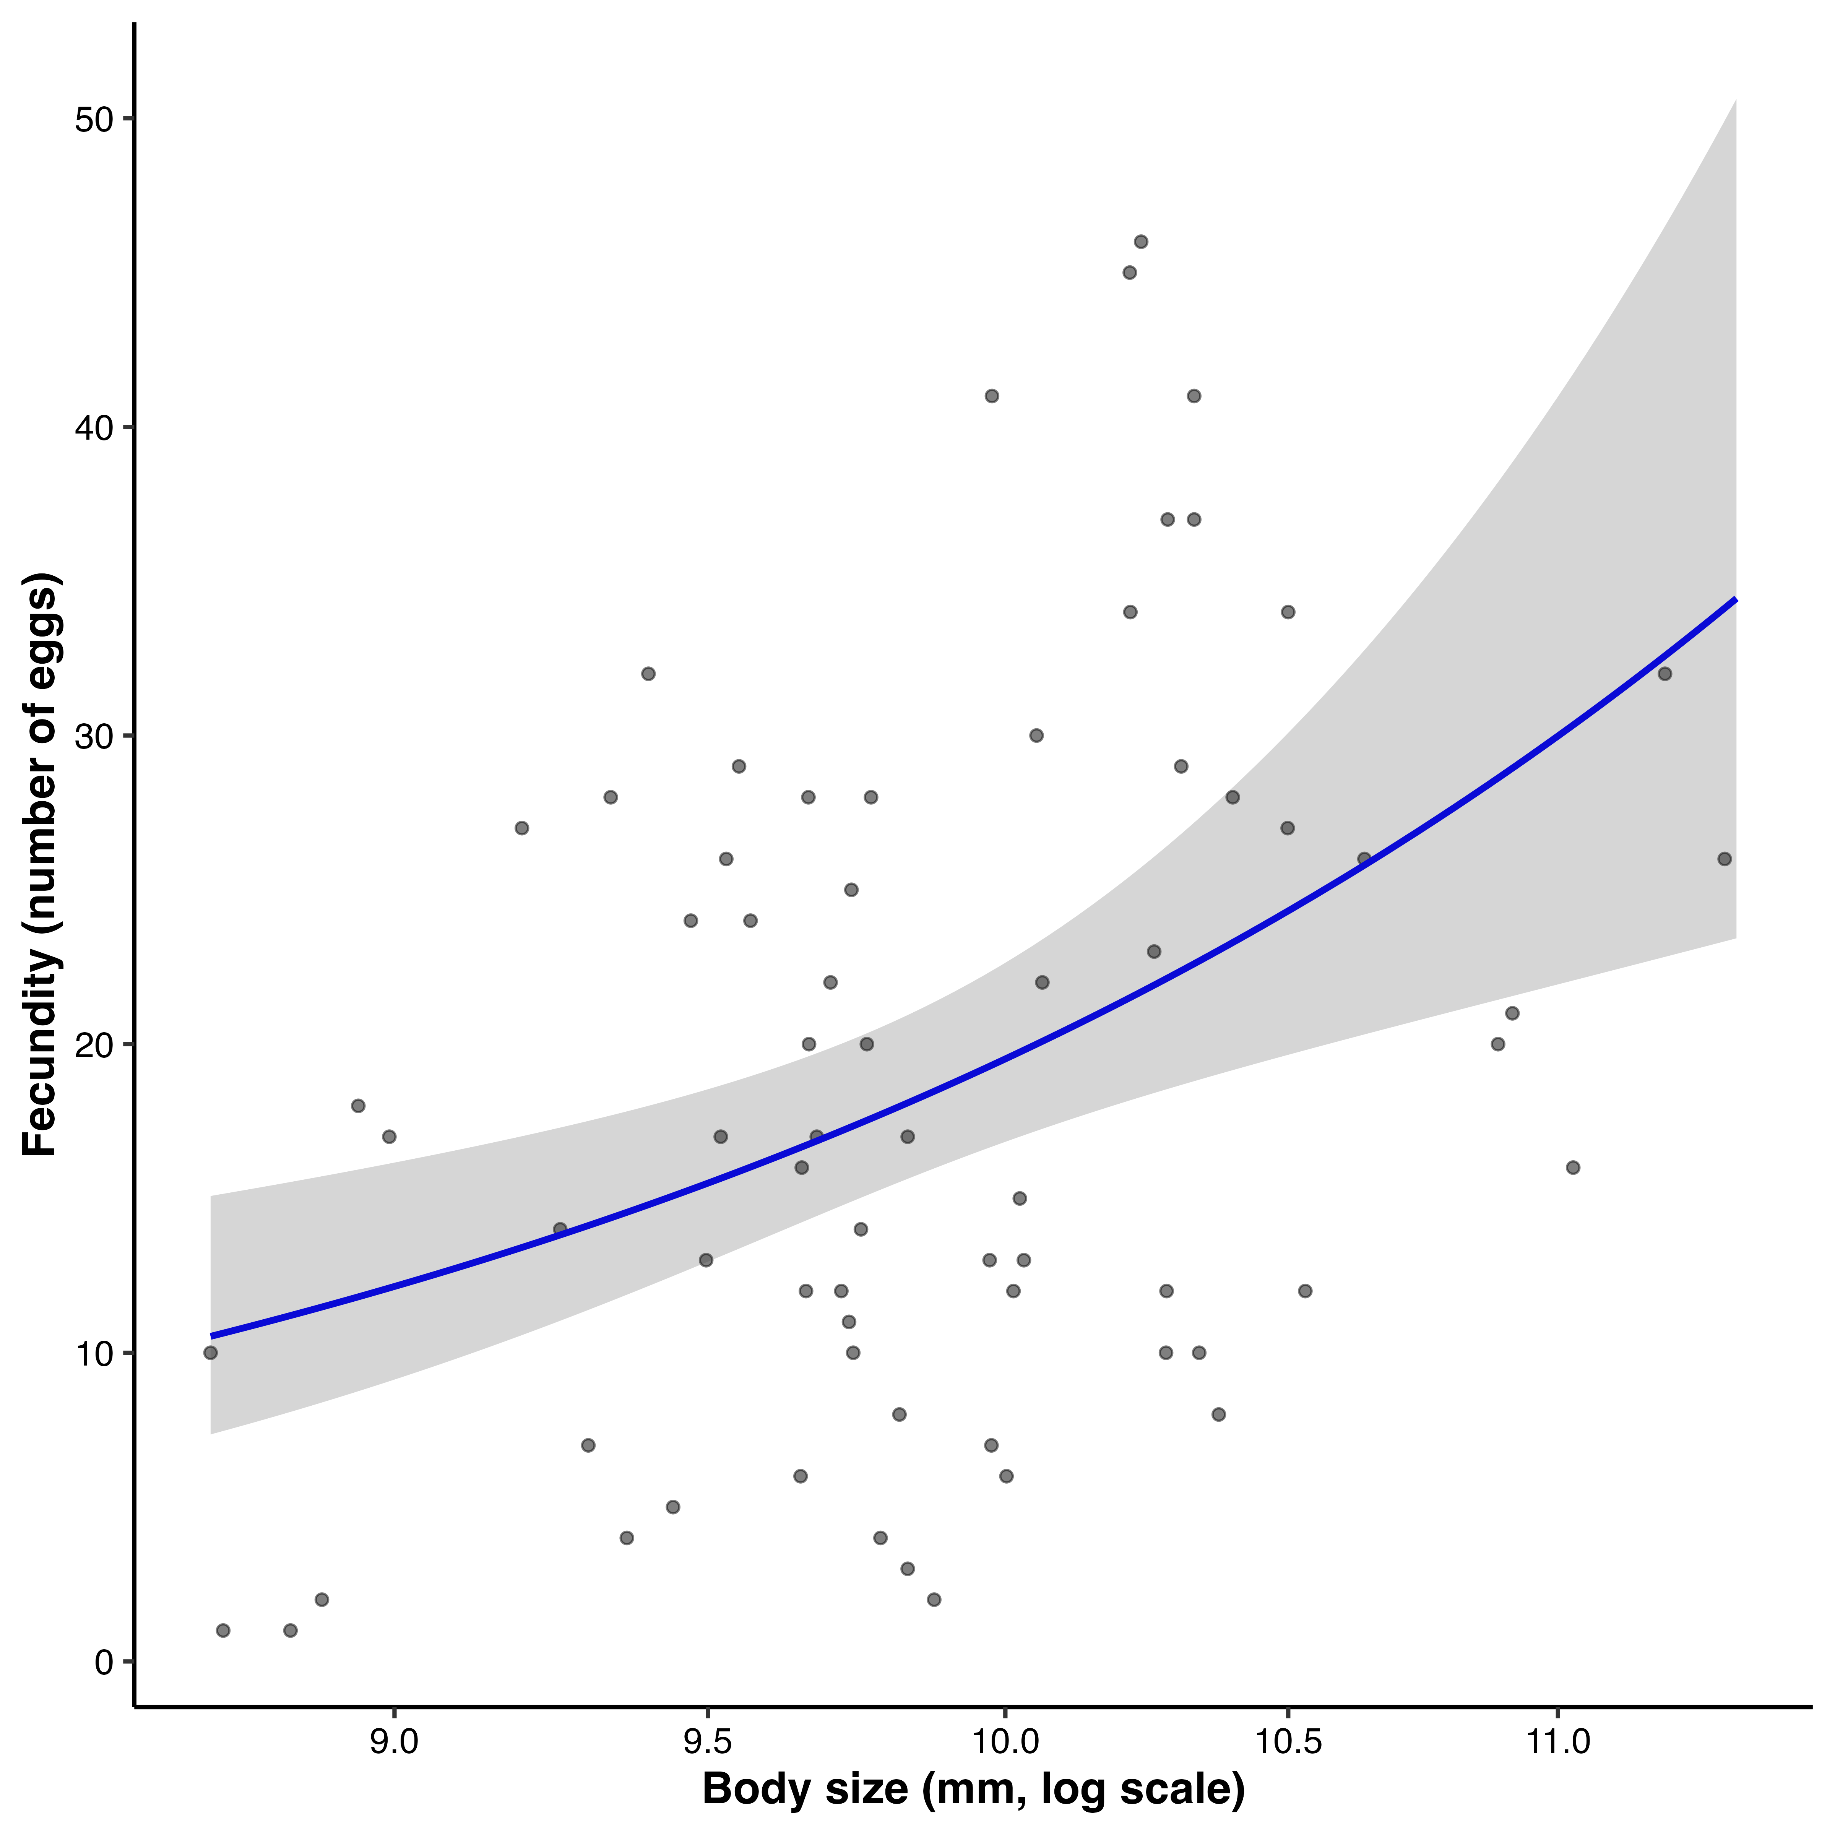
Figure 2: Relationship between female body size and fecundity. Points represent individual females, with fecundity measured as the total number of eggs produced. Body size is shown on a log scale (mm). The blue line indicates the fitted relationship from a generalized additive model, and the shaded region represents the 95% confidence interval. Fecundity increases nonlinearly with body size, with evidence for an accelerating (convex) relationship at larger sizes.

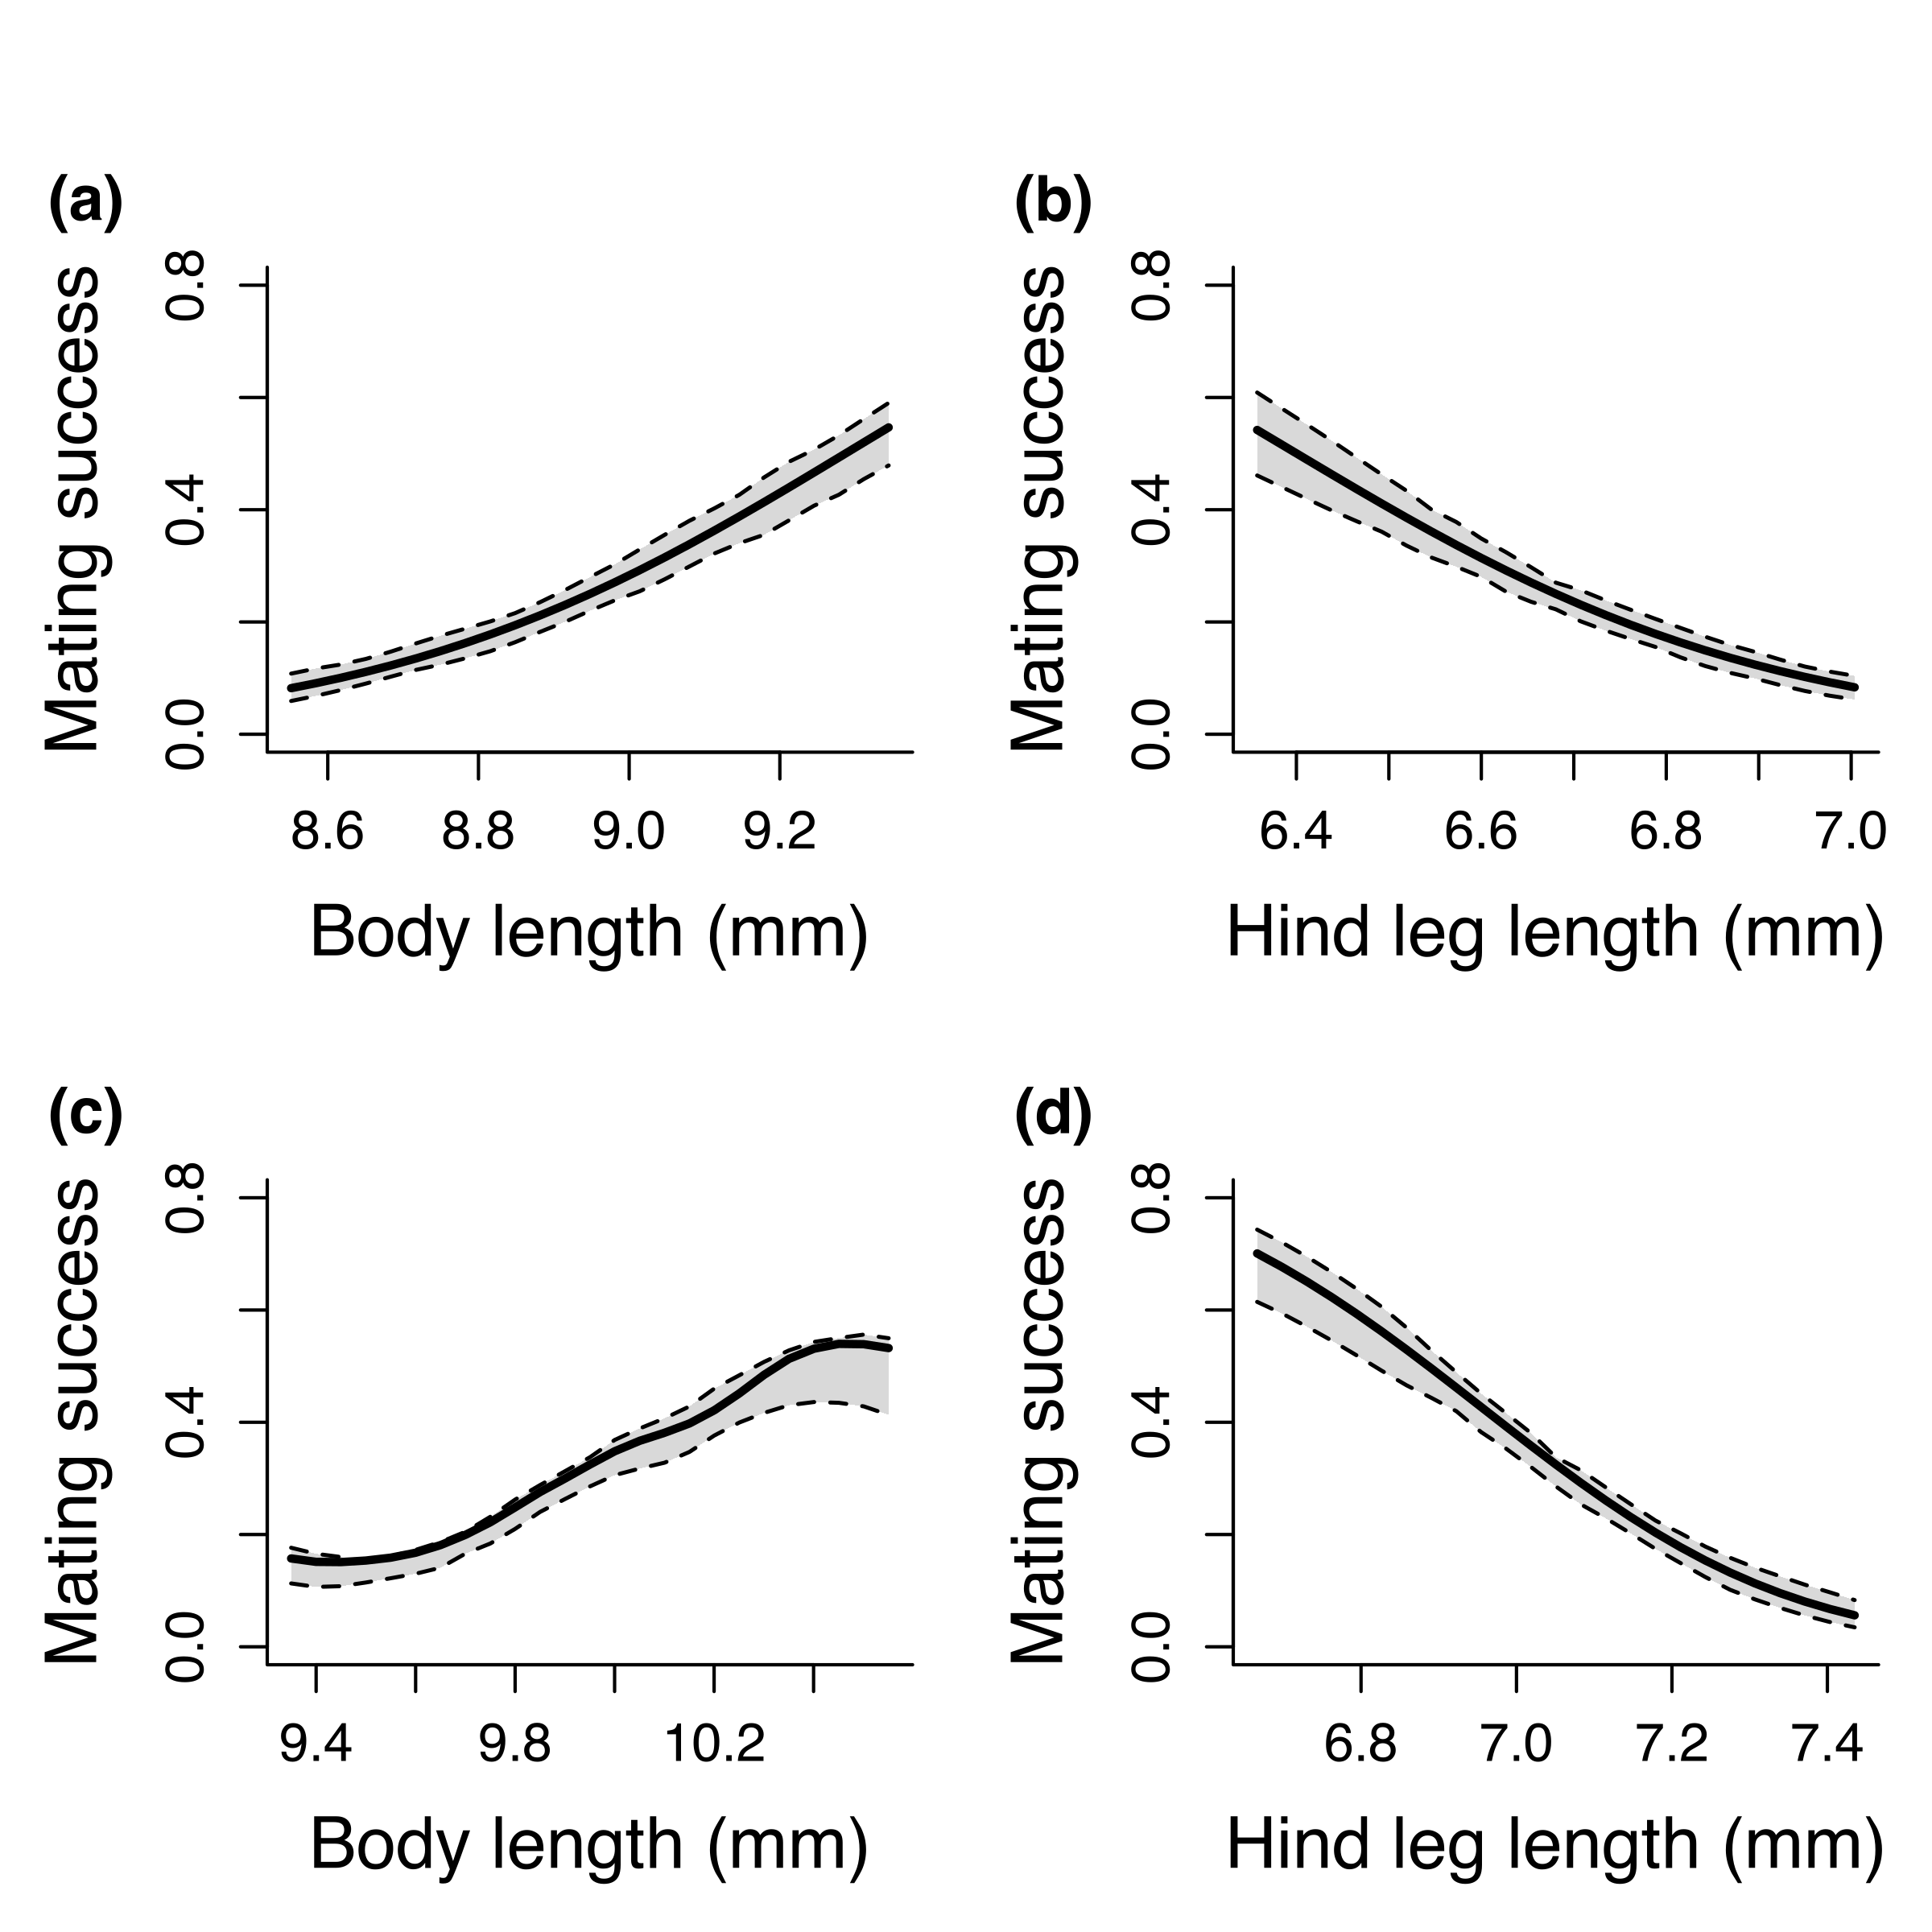
Figure 3: Fitness landscapes describing the relationship between morphology and mating success in males (a–b) and females (c–d). Panels show predicted mating success from generalized additive models as a function of body length (a, c) and hind leg length (b, d), with the alternate trait held constant. Solid lines represent model predictions and dashed lines indicate 95% confidence intervals estimated via parametric bootstrapping. Males exhibited positive directional selection on body length and negative directional selection on hind leg length, whereas females showed weaker positive selection on body length and negative selection on hind leg length. These patterns are consistent with estimates of linear selection gradients (β) reported in Table 1.

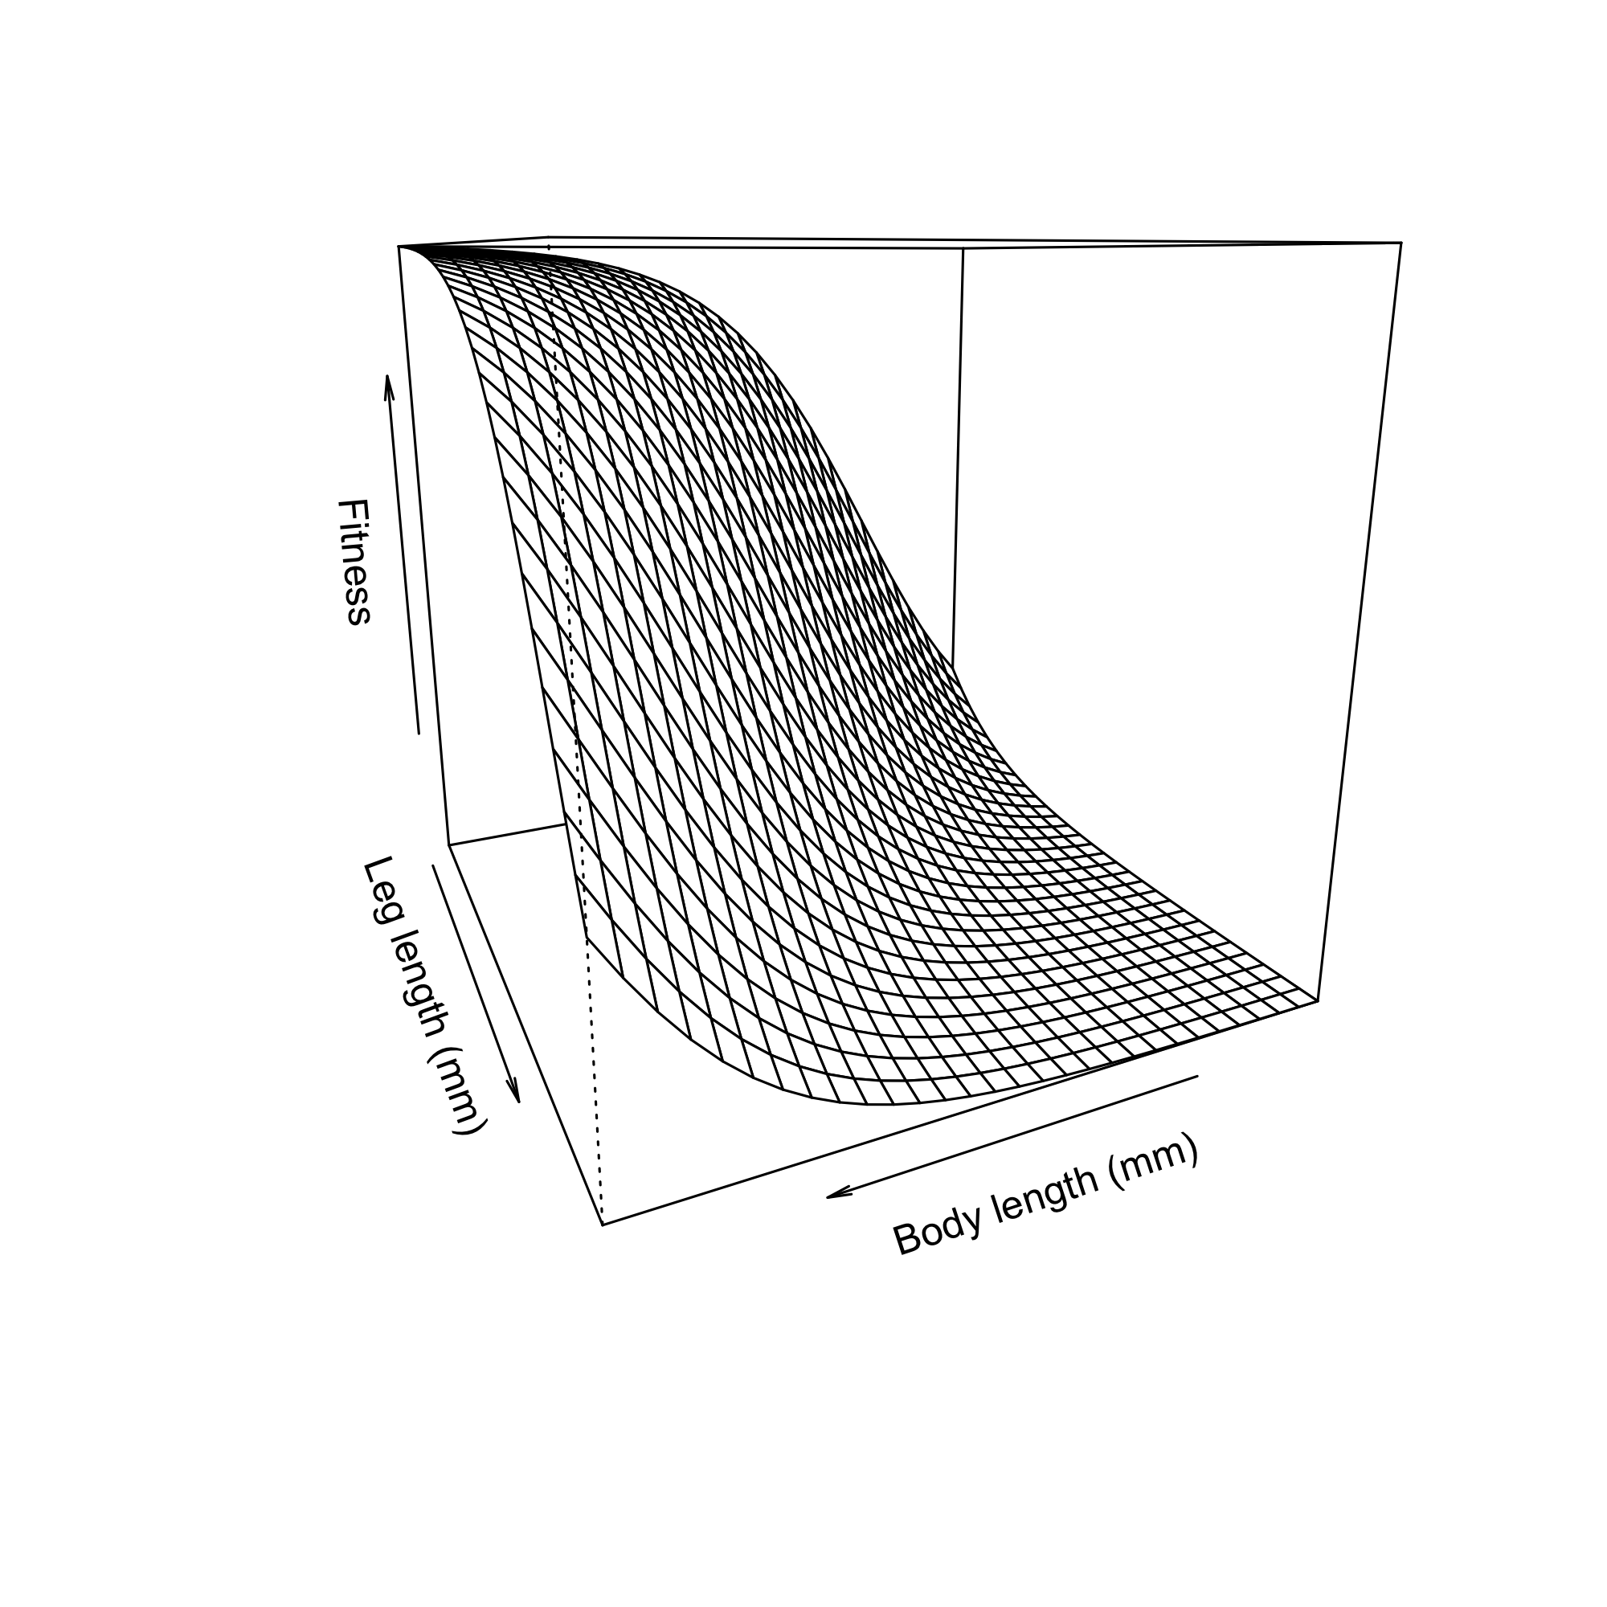
Figure 4: Fitness surface illustrating nonlinear and correlational selection on male morphology. Fitness is plotted as a function of body length and leg length (both in mm). The curved surface indicates strong nonlinear selection, with fitness highest for combinations of trait values along a ridge where relatively large body size is paired with shorter leg length. This pattern reflects negative correlational selection, indicating that the fitness consequences of one trait depend on the value of the other.

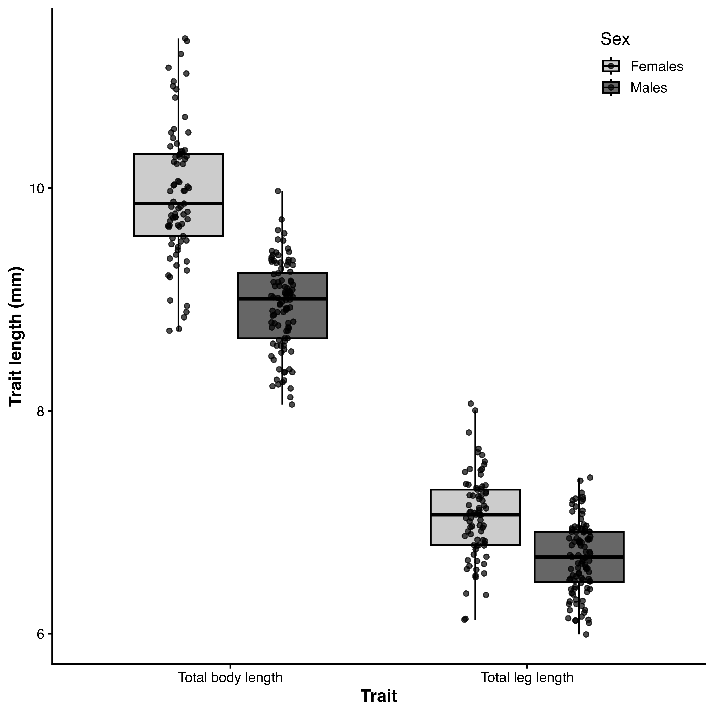
Figure 5: Sexual size dimorphism in body and leg morphology. Boxplots show total body length and total leg length (mm) for females (light grey) and males (dark grey), with points representing individual measurements. Horizontal lines indicate medians, boxes represent interquartile ranges, and whiskers extend to 1.5× the interquartile range. Females are larger than males for both traits, indicating female-biased sexual size dimorphism in overall body size and leg length.

